One-pager Project Description

**Links**

Github: <https://github.com/CodeReaper-10/student-management-system.git>

Application: <https://iconic-monitor-374112.el.r.appspot.com/students>

**Problem statement**

The purpose of the requirements document is to systematically capture requirements for the project and the system “**Student Management System**” to be developed. Both functional and non-functional requirements are captured in this document. It also serves as the input for the project scoping.

**Description:**

The amount of physical space consumed by using and maintaining hard bound paper books/registers are immense. Retrieval of information are also difficult and tedious.

**Proposed Solution with screenshots**

The aim is to replace the traditional system of using and maintaining hard bound paper books/registers for student management in an institution. This project needs zero maintenance from the user’s perspective and takes up no physical space as well. Hence, other than being an eco-friendly approach (as it is converting the management infrastructure into paperless), handling of data has also been made much easier. Being cloud native, it also makes this project accessible from anywhere, anytime. The project has been deployed using App Engine, hence rolling out up

**Scope of the System:**

The scope of the system is explained as follows:

* Enrolling a new student – Can be used by the authorities to enroll/register a new student who’s taking admission into the institution.
* Updating an existing student – Can be used by the authorities to update the details of an existing student as and when required.
* Deleting existing data – Can be used by the authorities to remove the information of an existing student who’s leaving the institution.
* Retrieving all existing information of students – Can be used by the authorities to view information of all the enrolled students in the organization.

**List of Google Cloud Services used**

* App Engine – To deploy the solution.
* Cloud SQL – To create an instance of SQL with MySQL as database engine.
* Cloud Storage – To design and implement the solution.

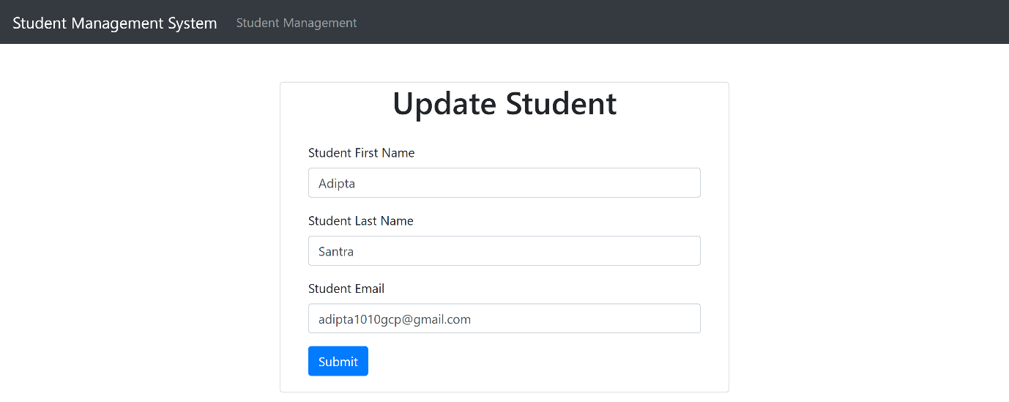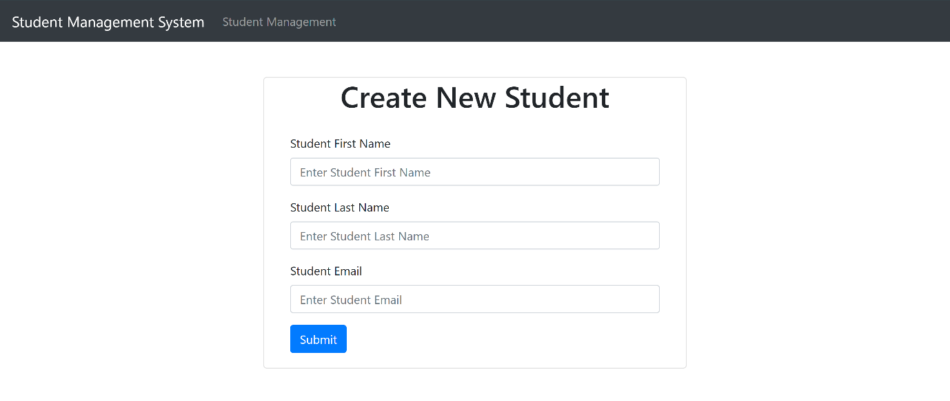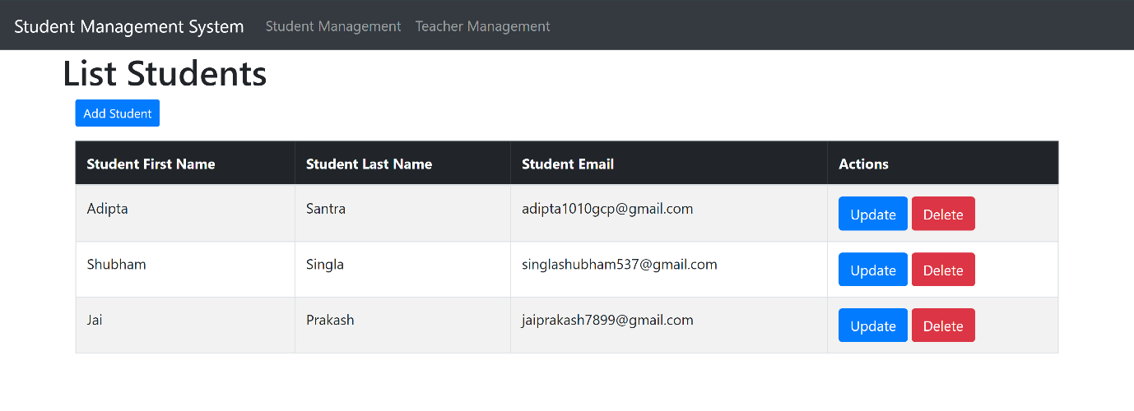**Project Screenshots:**

**Billing on services used:**

